**The Remaining Work:**

**AutoPostBack Page:**

**Code:**

**WFPostDemo.aspx.cs:**

protected void ListBox1_SelectedIndexChanged(object sender, EventArgs e)

{

if (ListBox1.SelectedItem != null) {

lblData.Text = "you selected " + ListBox1.SelectedItem.ToString();

}

else

{

lblData.Text = "Select any thing ";

}

}

**WFPostDemo.aspx**

<asp:ListBox ID="ListBox1" runat="server" AutoPostBack="True" OnSelectedIndexChanged="ListBox1_SelectedIndexChanged">

<asp:ListItem>Onkar</asp:ListItem>

<asp:ListItem>Raju</asp:ListItem>

<asp:ListItem>Kaju</asp:ListItem>

</asp:ListBox>

**Output:**

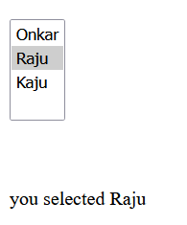

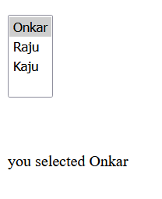

**Code:**

**Range Validator:**

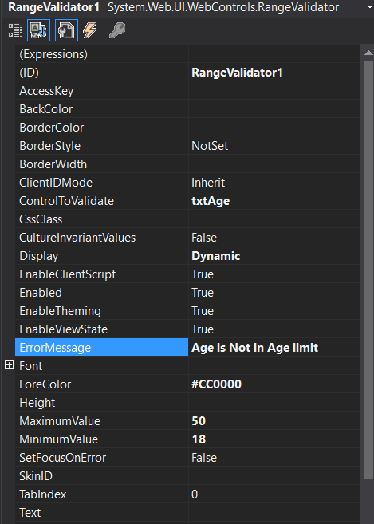

**WFValidation.aspx:**

<%@ Page Language="C#" AutoEventWireup="true" CodeBehind="WFValidation.aspx.cs" Inherits="PracticalNo2All.WFValidation" %>

<!DOCTYPE html>

<html xmlns="http://www.w3.org/1999/xhtml">

<head runat="server">

<title></title>

</head>

<body>

<form id="form1" runat="server">

<div>

&nbsp;&nbsp;&nbsp;&nbsp;&nbsp;&nbsp;&nbsp;&nbsp;&nbsp;&nbsp;&nbsp;&nbsp;&nbsp;&nbsp;&nbsp;&nbsp;&nbsp;&nbsp;&nbsp;&nbsp;&nbsp;&nbsp;&nbsp;&nbsp;&nbsp;&nbsp;&nbsp;&nbsp;&nbsp;&nbsp;&nbsp;&nbsp;&nbsp;&nbsp;&nbsp;&nbsp;&nbsp;&nbsp;&nbsp;

<asp:Label ID="Label1" runat="server" Font-Size="Large" ForeColor="#CC0000" Text="Validation Demo"></asp:Label>

<br />

<br />

&nbsp;&nbsp;&nbsp;&nbsp;&nbsp;&nbsp;&nbsp;&nbsp;&nbsp;&nbsp;&nbsp;&nbsp;&nbsp;&nbsp;&nbsp;&nbsp;&nbsp;&nbsp;&nbsp;&nbsp;

<asp:Label ID="Label2" runat="server" Text="Enter Name"></asp:Label>

:&nbsp;&nbsp;&nbsp;&nbsp;&nbsp;&nbsp;&nbsp;&nbsp;&nbsp;&nbsp;&nbsp;&nbsp;&nbsp;

<asp:TextBox ID="txtName" runat="server"></asp:TextBox>

<asp:RequiredFieldValidator ID="RequiredFieldValidator1" runat="server" ControlToValidate="txtName" Display="Dynamic" ErrorMessage="Name Required!!!" ForeColor="Red">Name is Mandatory!</asp:RequiredFieldValidator>

<br />

&nbsp;&nbsp;&nbsp;&nbsp;&nbsp;&nbsp;&nbsp;&nbsp;&nbsp;&nbsp;&nbsp;&nbsp;&nbsp;&nbsp;&nbsp;&nbsp;&nbsp;&nbsp;&nbsp;

<asp:Label ID="Label3" runat="server" Text="Password"></asp:Label>

&nbsp;&nbsp;&nbsp;&nbsp;&nbsp;&nbsp;&nbsp;&nbsp;&nbsp;&nbsp;&nbsp;&nbsp;&nbsp;&nbsp;&nbsp;&nbsp;&nbsp;&nbsp;

<asp:TextBox ID="txtPass" runat="server" TextMode="Password"></asp:TextBox>

<asp:RequiredFieldValidator ID="RequiredFieldValidator2" runat="server" ControlToValidate="txtPass" Display="Dynamic" ErrorMessage="Password Please" ForeColor="Red">Password Mandatory!</asp:RequiredFieldValidator>

<br />

&nbsp;&nbsp;&nbsp;&nbsp;&nbsp;&nbsp;&nbsp;&nbsp;&nbsp;&nbsp;&nbsp;&nbsp;&nbsp;&nbsp;&nbsp;&nbsp;&nbsp;&nbsp;&nbsp;

<asp:Label ID="Label4" runat="server" Text="Confirm Password"></asp:Label>

&nbsp;&nbsp;&nbsp;&nbsp;

<asp:TextBox ID="txtConPass" runat="server" TextMode="Password"></asp:TextBox>

<asp:RequiredFieldValidator ID="RequiredFieldValidator3" runat="server" ControlToValidate="txtConPass" Display="Dynamic" ErrorMessage="Confirm Password please" ForeColor="Red">Confirm Password is Mandatory!</asp:RequiredFieldValidator>

<asp:CompareValidator ID="CompareValidator1" runat="server" ControlToCompare="txtPass" ControlToValidate="txtConPass" Display="Dynamic" ErrorMessage="Password not same" ForeColor="#CC00FF"></asp:CompareValidator>

<br />

&nbsp;&nbsp;&nbsp;&nbsp;&nbsp;&nbsp;&nbsp;&nbsp;&nbsp;&nbsp;&nbsp;&nbsp;&nbsp;&nbsp;&nbsp;&nbsp;&nbsp;&nbsp;&nbsp;

<asp:Label ID="Label5" runat="server" Text="Enter Age:"></asp:Label>

&nbsp;&nbsp;&nbsp;&nbsp;&nbsp;&nbsp;&nbsp;&nbsp;&nbsp;&nbsp;&nbsp;&nbsp;&nbsp;&nbsp;&nbsp;&nbsp;&nbsp;

<asp:TextBox ID="txtAge" runat="server" TextMode="Number"></asp:TextBox>

<asp:RangeValidator ID="RangeValidator1" runat="server" ControlToValidate="txtAge" Display="Dynamic" ErrorMessage="Age is Not in Age limit" ForeColor="#CC0000" MaximumValue="50" MinimumValue="18"></asp:RangeValidator>

<br />

&nbsp;&nbsp;&nbsp;&nbsp;&nbsp;&nbsp;&nbsp;&nbsp;&nbsp;&nbsp;&nbsp;&nbsp;&nbsp;&nbsp;&nbsp;&nbsp;&nbsp;&nbsp;&nbsp;

<asp:Label ID="Label6" runat="server" Text="Enter Email:"></asp:Label>

&nbsp;&nbsp;&nbsp;&nbsp;&nbsp;&nbsp;&nbsp;&nbsp;&nbsp;&nbsp;&nbsp;&nbsp;&nbsp;&nbsp;

<asp:TextBox ID="txtEmail" runat="server" TextMode="Email"></asp:TextBox>

<asp:RegularExpressionValidator ID="RegularExpressionValidator1" runat="server" ControlToValidate="txtEmail" Display="Dynamic" ErrorMessage="Check Email ID" ForeColor="#CC0000" SetFocusOnError="True" ValidationExpression="\w+([-+.']\w+)*@\w+([-.]\w+)*\.\w+([-.]\w+)*">Please Enter Proper Email</asp:RegularExpressionValidator>

<br />

&nbsp;&nbsp;&nbsp;&nbsp;&nbsp;&nbsp;&nbsp;&nbsp;&nbsp;&nbsp;&nbsp;&nbsp;&nbsp;&nbsp;&nbsp;&nbsp;&nbsp;&nbsp;&nbsp; Enter Prime Number:<asp:TextBox ID="TextBox1" runat="server"></asp:TextBox>

<asp:CustomValidator ID="CustomValidator1" runat="server" ControlToValidate="TextBox1" OnServerValidate="CustomValidator1_ServerValidate">Only Prime Number</asp:CustomValidator>

<asp:Label ID="PrimeLBL" runat="server"></asp:Label>

<br />

<br />

&nbsp;&nbsp;&nbsp;&nbsp;&nbsp;&nbsp;&nbsp;&nbsp;&nbsp;&nbsp;&nbsp;&nbsp;&nbsp;&nbsp;&nbsp;&nbsp;&nbsp;&nbsp;&nbsp;&nbsp;&nbsp;&nbsp;&nbsp;&nbsp;&nbsp;&nbsp;&nbsp;&nbsp;&nbsp;&nbsp;&nbsp;&nbsp;&nbsp;&nbsp;&nbsp;&nbsp;&nbsp;&nbsp;&nbsp;&nbsp;&nbsp;&nbsp;

<asp:Button ID="btnSubmit" runat="server" Font-Size="Large" Text="Submit" OnClick="btnSubmit_Click" />

<br />

<br />

<br />

</div>

</form>

</body>

</html>

**WFValidation.aspx.cs:**

using System;

using System.Collections.Generic;

using System.Linq;

using System.Web;

using System.Web.UI;

using System.Web.UI.WebControls;

namespace PracticalNo2All

{

public partial class WFValidation : System.Web.UI.Page

{

protected void Page_Load(object sender, EventArgs e)

{

}

protected void btnSubmit_Click(object sender, EventArgs e)

{

}

protected void CustomValidator1_ServerValidate(object source, ServerValidateEventArgs args)

{

if (Convert.ToInt32(args.Value) % 2 == 0)

{

PrimeLBL.Text = "Valid Number";

}

else

{

PrimeLBL.Text = "Not Valid Number";

}

}

}

}

**Output:**

